How k means works

Let’s assume that our k equals 3 and this is our dataset:
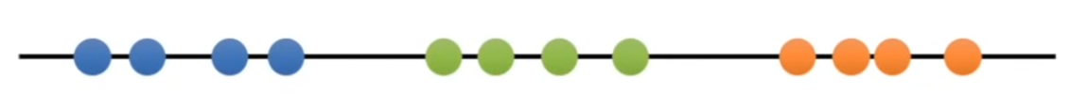

In order to perform k means clustering at first we need to:
- choose ‘k’ value which indicates how many cluster we want to create

- Select 3 random points (because k = 3) from the dataset:
Each of those points represents one cluster

- Each point from the dataset we assign to the closest cluster:
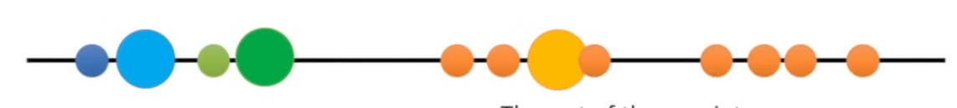

- Calculate the mean of each cluster:
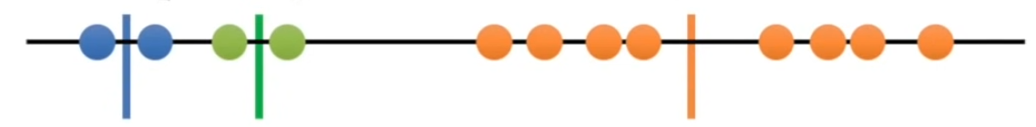

- Now those means represents 3 clusters and we do what we did before- assign each point to the closest cluster:
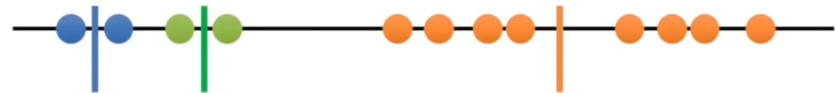

- If in the previous step we obtained the same clusters as previously we are done. If we obtain new clusters then again we calculate a mean of each cluster and assign points to clusters

- We repeat this process a given number of times but every time we choose different starting points

- Every time we perform clustering we calculate a variation in each cluster and add those values together. This is the score of our clustering and we choose clustering for which the total variation is the smallest

How to choose k value and evaluate a model

In order to choose the best k value we perform clustering for different k values and we check how the total variation is changing. For bigger k we always have a smaller variation. We should choose such a k that for bigger k we don’t obtain a significant reduction in the total variation. For example if we see that for k = 3 we have much smaller variation than for k = 2 but for k = 4 we have only a little bit smaller variation then for k = 3 we should choose k = 3, like here:
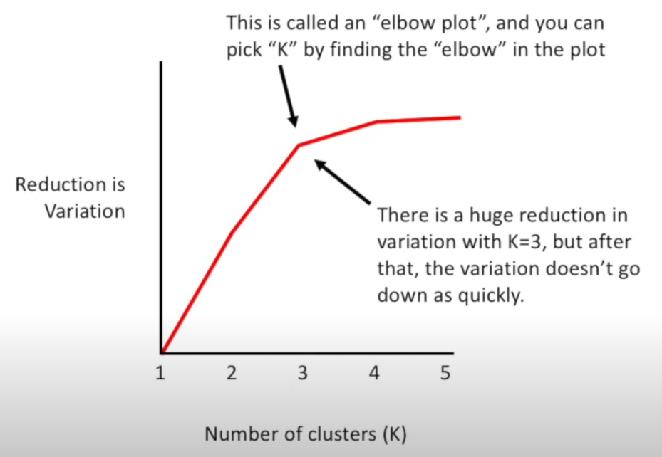

In order to check which cluster is the closest to the given point we can use for example the Euclidian distance.

- Inertia is a value which measures how good is our clustering. The lower value indicates better clustering, that is data in each cluster is more similar. Inertia is a sum of SSEs (sum of squared errors) for all clusters.

